My Final Gifts
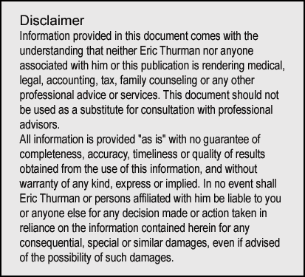
INSTRUCTIONS

Leave good memories for the people you love. Notes you give people to read after you die and conversations you have with people shortly before you pass will be among the most appreciated words you will ever express to family and friends.
This process is simple:
- Make a list of people who are important in your life.
- Prepare what you want to say.
- Arrange for your messages to be delivered after you die.

You don’t have to be near death to prepare these messages. Planning well in advance is always a good idea. And don’t let this task overwhelm you. Pace yourself. Perhaps you should to writing only 2 or 3 messages each day. Don’t get tired or give up. Complete your list.
If you don’t think you have a knack for writing, you will find suggestions below that can help you. They are easy to follow.

Make your list:
Family members
Your spouse
Your children and their spouses if they are married
Your grandchildren
Your brothers and sisters
Your parents if they are living
Any other relatives who have been important in your life

People you enjoy most
Friends
Neighbors
Others who you consider special people in your life

People you miss most
Who are the people who no longer live near you but matter to you?
Add anyone who is special to you but is not on one of the earlier lists.

People who are estranged from you
Relatives or friends, even if you haven’t spoken for years.

What you can say:
Messages like these often mean more than possessions people inherit. A personal note from you is a matchless gift and will be highly treasured.

Make your goodbyes good. Stay positive with everyone. This is not the time to complain, correct, or give advice. Be gentle and loving.

If you are worried about what to write, remember this. A short message is better than no message. Some of your notes may be as short as,

“As I realize my life is near its end, I wanted
to be sure that I said to you one more time, I love you.”

A plain blank greeting card works well for a short note.

Medical doctor Ira Byock wrote a book, The Four Things That Matter Most, that outlines four thoughts that people do well to express as they approach the end of life.
“I love you.”
“Thank you.”
“I forgive you.”
“Forgive me.”

All you need to do is start with one of the short sentences above and add another remark or two. Share your feelings. They will be a marvelous gift to the person who receives your note.

How to deliver your messages:
You have several choices.

As described earlier, you can write short notes, perhaps on greeting cards. If you are inclined, writing long letters would be wonderful, but “long” is not necessary.

Meet in person or by phone. This is usually best if you have a terminal diagnosis and are within the final days or weeks of your life. If you fear a conversation might be awkward, collect your thoughts ahead of time and make a note for yourself about what you want to be sure to say.

Would you be more comfortable talking a short message into a recording? Many people know how to make sound recordings or videos using their mobile phones. If you aren’t sure how to make and save recordings, ask someone to help you. Be certain your helper has a plan to save the recording, so it can be delivered to the right person following your death.

An important last step is to have someone collect all your messages, hold them, and then distribute them as you wish at the appropriate time.

